Leia o texto e responda às questões

PARTS OF COMPUTERS

Inside the computers

Você já viu algum computador aberto? Nesta aula iremos abordar as peças que compõem a parte interna dos computadores e sua função para o funcionamento pleno de toda a máquina.
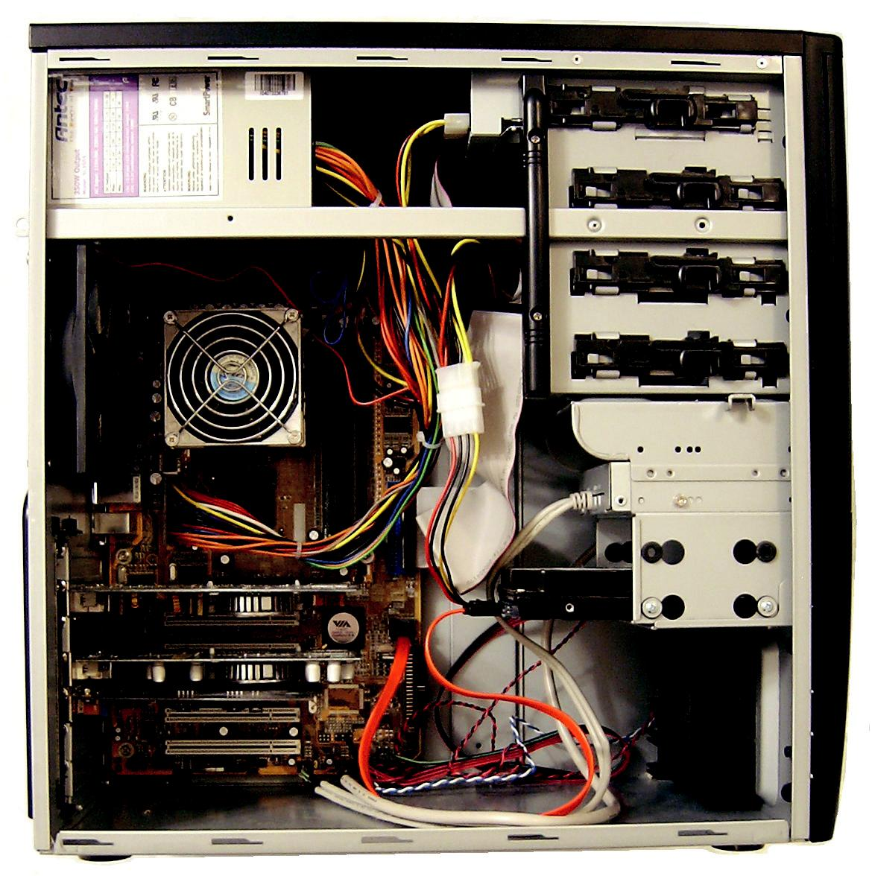

Figura 4.1: Gabinete aberto

Fonte: http://groovix.com/images/inside1.jpg

- The case

The computer case is a very important part of the computer. It protects all of the electronic components inside and provides adequate ventilation to prevent overheating.
The case also should be capable of allowing you to expand your hardware if the need arises. The ATX case is the one most commonly used today.

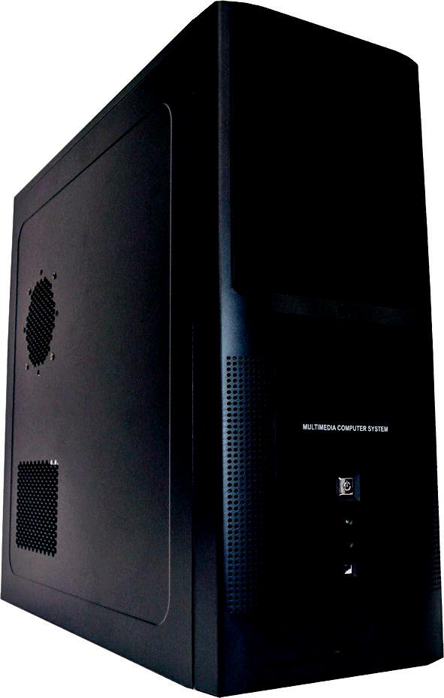

Figura 4.2: Gabinete

Fonte: http://blogs.windowsnetworking.com/wnadmin/wp-content/blogs/33/files/2006/06/115140028653.jpg

- The motherboard

A motherboard is the central printed circuit board in many modern computers and holds many of the crucial components of the system, while providing connectors for other peripherals. The motherboard is sometimes alternatively known as the main board, system board, or, on Apple computers, the logic board.

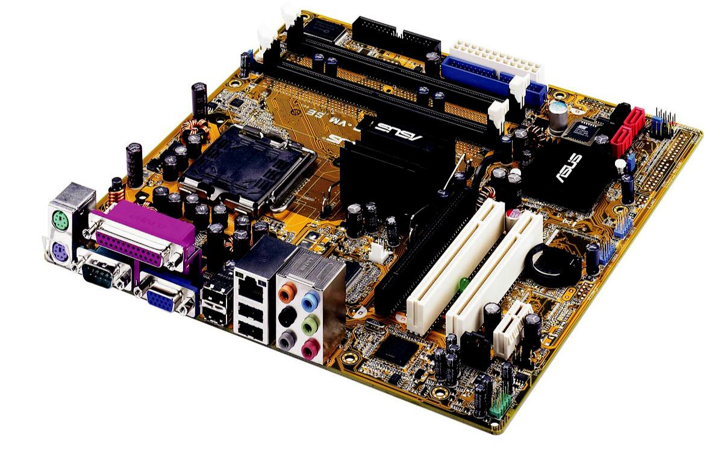

Figura 4.3: Placa mãe

Fonte:http://www.sxc.hu

The term mainboard is archaically applied to devices with a single board and no additional expansions or capability. In modern terms this would include embedded systems and controlling boards in televisions, washing machines, etc. A motherboard specifically refers to a printed circuit with the capability to add/extend its performance.

- The power supply

The power supply supplies the electrical power for a computer. It supplies power to the motherboard, drives, and certain expansion cards. It normally has at least one fan that helps cool the power supply and will assist in the task of cooling the computer.

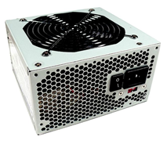

Figura 4.4: Fonte de alimentação

Fonte: http://www.sxc.hu

Some power supplies have an additional outlet on the back that can be used to provide power to the monitor. Power supplies come in a variety of wattages. They range anywhere from around 160 watts to about 700 watts. 350 to 400 watts power supplies are probably the most common.

- RAM memory

RAM is an abbreviation for Random Access Memory. RAM is the computer’s main memory. The computer uses RAM constantly to temporarily store information while it is working with it.

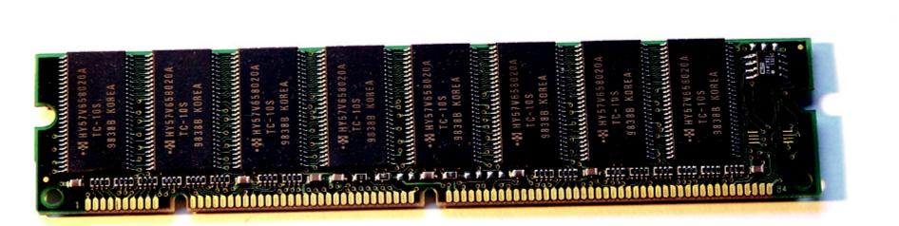

Figura 4.5: Memória RAM

Fonte: http://www.megamamute.com.br/Imagens/produtos/94/63594/63594_Ampliada.jpg

The speed of the memory, or its data transfer rate, is how fast the data can travel between the RAM and the processor. The speed is measured in MHz (megahertz). One megahertz is one million frequency cycles per second. Data travels at a pace of 100 million cycles per second with 100MHz memory.

- The case fan

Case fans are relatively inexpensives and are extremely importants. Computer components generate quite a bit of heat and must be kept as cool as possible. The case fan is the primary source of cooling for most computers. Although the importance of the fan is often overlooked, it is the key to a long life for a computer. Most computer cases are designed to allow a person to add one or more additional case fans.

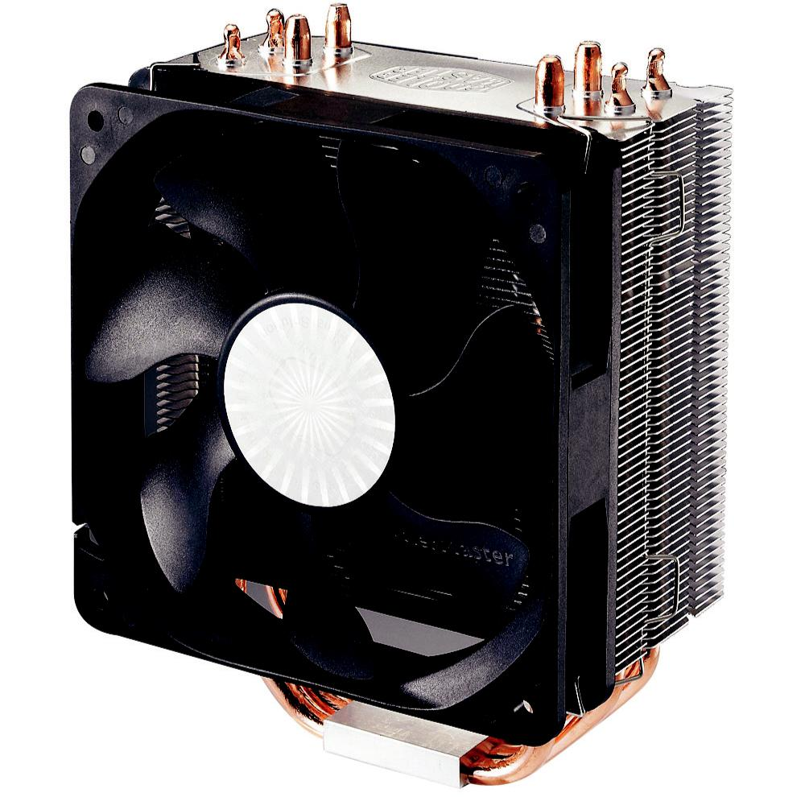

Figura 4.6: Case fan

Fonte: http://images.bit-tech.net/content_images/2009/11/investigating-sata-6gbps-performance/sg2.jpg

- Hard disk (HD)

Your computer’s hard disk drive stores information on a hard disk, a rigid platter or stack of platters with a magnetic surface. Because hard disks can hold massive amounts of information, they usually serve as your computer’s primary means of storage, holding almost all of your programs and files.
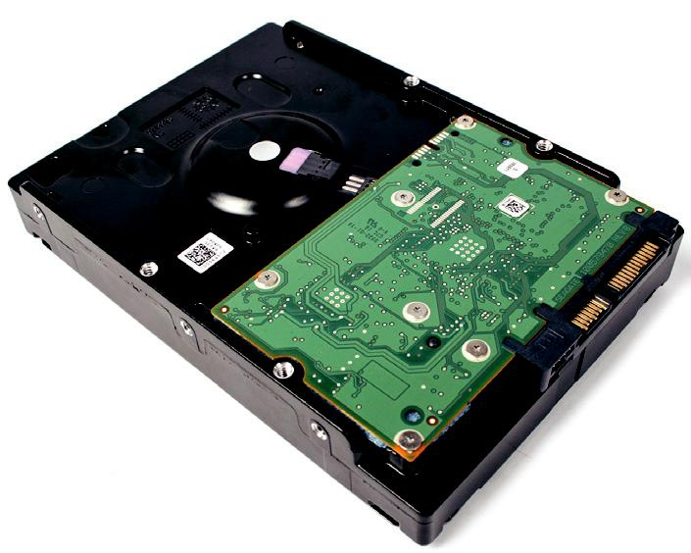

Figura 4.7: Disco rígido

Fonte: http://www.sxc.hu

The hard disk drive is normally located inside the system unit.
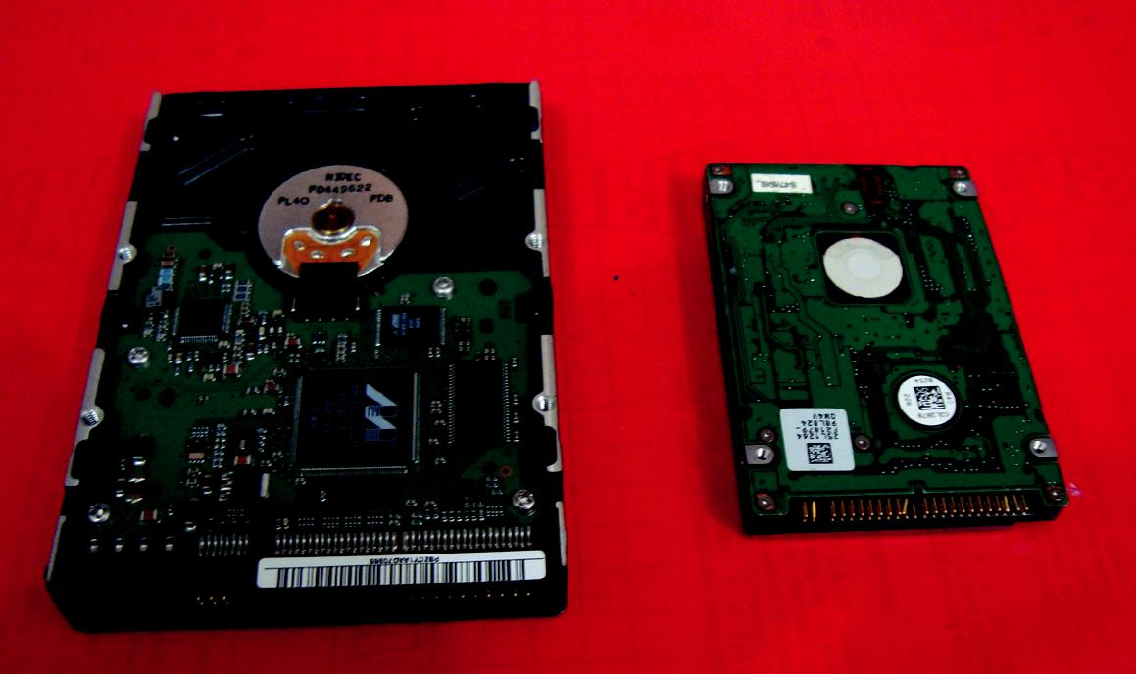

Para conhecer exemplos diários utilizando verbos, assista ao vídeo disponível no endereço http://www.youtube.com/ watch?v=yWccPqg1DbI

É bem divertido. Depois de ter assistido ao vídeo, tente escrever as frases que tiver entendido e deposite no fórum do AVEA

Figura 4.8: Comparação entre HD de desktop e de notebook

Fonte: Acervo da autora

- Quais são as principais partes do computador tratadas no texto.

Practically all the components discussed in the text are essential parts of a computer, but if I had to choose some in order of importance I would say that the motherboard since that is where many components of the computer and the
The power supply since it is the one that delivers the energy to the vast majority of the components, making its use possible.

- Encontre as seguintes informações no texto

- Normalmente tem pelo menos um ventilador que ajuda a refrigerar a fonte de alimentação e ajudará na tarefa de resfriamento do computador.
Line:14-15

- Embora a importância do ventilador seja frequentemente ignorada, ela é a chave para uma longa vida útil de um computador.
Line:29-30

- A placa mãe é, por vezes, conhecida alternativamente como placa principal, placa do sistema, ou, nos computadores Apple, placa lógica.
Line:7-8

- Porque os discos rígidos podem conter grandes quantidades de informação, eles servem geralmente como o principal meio de armazenamento do seu computador, contendo quase todos os seus programas e arquivos.
Line:33-35

- Ela protege todos os componentes eletrônicos no seu interior e proporciona ventilação adequada para evitar o superaquecimento.
Line:1-2

- Qual o sentido dos conectores (razão/motivo, adição, contradição, tempo)

- And (linha 2): adição.

- Or (linha 8): adição.

- Although (linha 29): contradição

- Because (linha 33): razão/motivo

FONTE: ARAUJO, F.M. Inglês para informática. Manaus: Centro de Educação Tecnológica do Amazonas, 2010.

